**The importance of the cooperation between the business community and the civil society for building a better society**

**Event report**

**Introduction**

On 29th September the Civil Society Resource Centre organised the event "The importance of cooperation between the business community and the civil society for building a better society" on the ZOOM platform with the participation of about 40 CSOs’ representatives. The event was implemented in partnership with the association Konekt, Skopje. The purpose of the event was to raise awareness but also to inform organisations about the importance, potential and opportunities for mobilizing resources and cooperation with the business sector in the country, to give practical advice to CSOs on how to start and develop approaches to mobilize resources from businesses and provide space for the exchange of experiences and advice on this topic.

The event was opened by **Valentina Atanasovska** from the Macedonian Center for International Cooperation, who greeted the attendees and presented the event’s objectives.

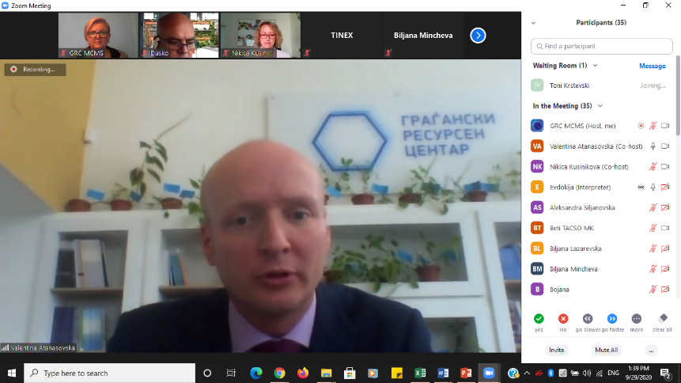At the opening, **Freek Janmaat**, Head of Section on Economic Issues, Institution Building and Cross Border Cooperation, Delegation of the European Union, pointed out that achieving sustainable development requires proactive partnership among all society stakeholders: government, civil society, business community, media. Strong partnership between business and civil society may pool resources and knowledge in a vital driver for societal change. Models for sustainable cooperation of these two crucial stakeholder groups may hold the key to reinvent economic growth on the basis of a new circular economy, as a key priority in the European Green Deal.

The DG Enlargement Guidelines for EU support to civil society in enlargement countries acknowledge that the financial sustainability of CSOs also requires improved capacity for diversified fundraising, targeting not only public, but also private sources of income. Civil society has a strong potential to provide services to the business community. Unleashing this potential not only strengthens the local funding sources for CSOs, but also creates platforms that both sectors can utilize to pursue common goals.

**Session 1: Cooperation between the business community and the CSOs during COVID-19**

**Dushko Hristov**, president of the Food Bank, began his speech with information that the same day marks for the first time the first international day for raising awareness of food loss and waste. The Food Bank stores surplus food, registers it in its warehouse, and then delivers it to the users, as a kind of the fastest humanitarian post and donation. Dushko reported that since the beginning of the crisis in March, they have collected and delivered over 160 tons of food to over 4,500 families. During their existence of almost a decade, they have constantly cooperated with the business community, and today they cooperate with a total of 24 companies that continuously donate food according to the possibilities. At the very beginning of Food Bank, they sent over 2000 information letters to individuals, municipalities and companies. The purpose was to inform about the organisation’s activities, to which they received 23 feedbacks, including a call for future cooperation with Tinex markets. Thus, from 2013 until today, thanks to the cooperation between the Food Bank and Tinex, every day over 300 people from 11 cities in the country receive bread and pastry. He stressed that only through the Tinex Bio-program that started last year, Tinex donates 227,000 MKD per month, while the donation of bread and pastry is between 3.8 and 4.2 million MKD annually.

**Useful tips for achieving successful cooperation with the business community:**

* The cooperation is possible, but it can be maintained only with continuous achievement of results and with transparent and accountable work and great commitment;
* Honest approach, commitment, persistence and perseverance are a guarantee of success and good cooperation between CSOs and the business community;
* In addition to the business community, the cooperation with the institutions (in this case the municipalities) is especially important for achieving the final results (provision of premises, transport vehicles, etc.). Food distribution is currently the largest cost incurred by the Food Bank;
* CSOs sticking together when approaching the business community increases the chances for cooperation.

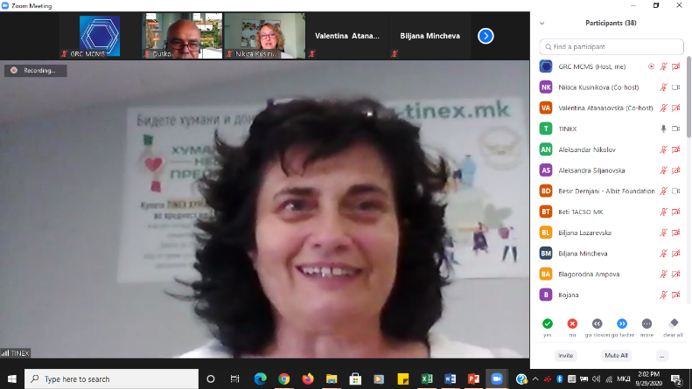**Sonja Bojarovska** responsible for social responsibility in the company Tinex emphasized that Tinex continuously donates, cooperates with the public sector and with organisations. They cooperate with the association Izbor from Strumica which through its therapeutic workshop Meal produces organic certified food which is then sold in the markets of Tinex. They have been cooperating with the Food Bank for a long time, last year they introduced a new form of cooperation in order to develop the management of surplus food, and this year they introduced online donation. The surplus food is created from the import of organic dairy products, and a few days before their expiration, they donate the items to the Food Bank, whereas the end users are from the association Reto, village Batinci, Skopje, an association that helps narcotics addicts in their resocialization. With the beginning of the pandemic, on the idea of ​​the Food Bank, on their website E-shopping Tinex, they made a Donation Package of 5 basic items that costs 198 MKD, opening the opportunity for humanitarian consumers to donate to those in need. When the number of purchased packages exceeds 100, they organise with the Food Bank and donate it where it is most needed at the moment.

Bojarovska advised the organisations from the very creation of the idea through the implementation to communicate with the business community, to create the idea and to develop the project together.

**Session 2: Opportunities for continuous cooperation between the business sector and CSOs**

**Besir Dernjani**, executive director of ALBIZ Foundation informed that the foundation was founded in 2011 by the company Dauti Komerc as a Dauti Foundation, as a model for social responsibility and philanthropy. In 2016, the foundation was renamed to ALBIZ Foundation, where the company Dauti Komerc was joined by 15 other companies as founders of the foundation. Today, over 40 companies express their social responsibility through the programs of the ALBIZ Foundation.

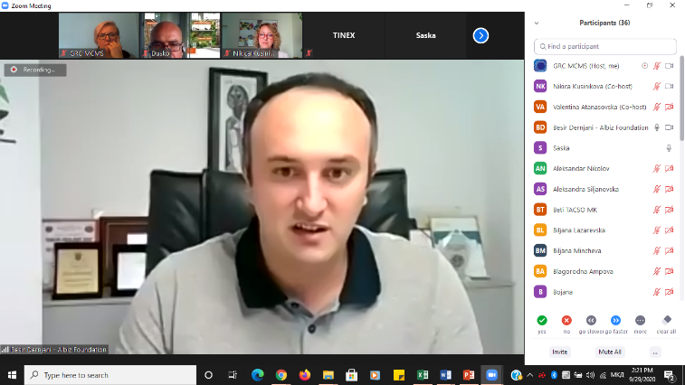The ALBIZ Foundation aims to promote corporate social responsibility and philanthropy by organizing and initiating educational, economic, social, infrastructure programs for the development of society.  
The Foundation has excellent cooperation with other CSOs, such as the informal platform for cooperation between CSOs and the business sector, established within an EU-funded project. The good cooperation between the members of the informal platform resulted in a successful application for an EU-funded project.

In addition to its annual programs and projects, the ALBIZ Foundation provides direct assistance to various educational, social, health institutions and CSOs, cultural, artistic associations, sports clubs, supporting projects and activities that are in line with the vision and mission of the Foundation.

Besir stressed the importance of establishing good cooperation with one or two companies first, that would then give a good recommendation to other companies. Additionally, he advised that companies would like to be involved in the implementation and not just provide financial resources.

**Aleksandra Petrovska Gorin** from Pharmachem mentioned several types of support and cooperation with CSOs. Pharmachem is a long-time buyer of the magazine Face to Face of the association Public and thus provides assistance to people with disabilities who sell these magazines. They continuously cooperate and support the association SOS Children's Village, and in March they gave a one-time donation. Pharmachem also cooperates with the municipality of Gjorce Petrov by helping pensioners, sports clubs, etc. in various ways.

Alexandra emphasized the cooperation with the Union of Scouts of Macedonia, underlining that the association Konekt was a mediator in establishing this relationship. As part of this cooperation, the Union of Scouts brings scouts’ patrols to visit their environmental laboratory, in order to educate the children.  
In the end, Alexandra pointed out that in addition to the will and desire to cooperate with the NGO sector, support is needed from the top management of the company as well as the strategic commitment of the company to be towards socially responsible corporate actions.

**Ljupcho Krstevski** from the Local Action Group, Prespa, who are dedicated to the transformation of organic waste into compost and other organic fertilizers, gave a successful example of applying the circular economy and creating synergy in the local community. They identified an opportunity for cooperation with companies that generate organic waste as well as companies that need processing of organic waste. Consequently, they started cooperating with a poultry farm in Resen, with the companies that process the apple and get the pulp as a by-product, as well as with companies that generate sawdust and other components needed to produce quality fertilizer. LAG, Prespa helped them in the initiative with knowledge and practical work, creating several thousand cubic meters of compost, which they then expanded to farmers, as well as another related company that works with apples and other fruits in Resen. They also work with a laboratory where the quality of the compost can be tested.

As advice to other organisations, Ljupcho pointed out that great commitment is needed, the association should have a focus in its work but also good knowledge and expertise in the field. Companies want to see that organisations have sincere intentions.

During the discussion, Aleksandar Nikolov from the association Zenit, shared the experience from the EU-funded project through which a model was developed for providing a specific service to companies. The service consists of certifying the companies for a fair relationship with the consumers, for which the companies pay, and the income is intended for the CSOs. The model includes 14 organisations, whose capacities are built to provide this service, and so far 50 companies have passed the certification process.

Kiril Ristovski from the Centre for Environmental Democracy FLOROZON shared a success story of cooperation with Tinex, Elida from Kumanovo and some other market chains in providing waste bins for collection and disposal of potentially contaminated waste after the start of the COVID-19 pandemic. This approach was also supported by the public utility services, and they have already signed several memoranda of cooperation with them.

**Session 3: Donations and sponsorships for building an inclusive society**

**Nikica Kusinikova** held a one-hour lecture on the topic with concrete examples, guidelines and tips for establishing and maintaining successful cooperation with the business community.

At the beginning, Nikica informed that despite the successful examples, the organisations face barriers in the cooperation with the companies. One reason is the existence of stereotypes, i.e. organisations often see the business community as profiteers, as a bag of money that they have to open for organisations, a relationship that businesses do not accept. Often the two sectors speak a different language, i.e. companies often do not understand the CSOs’ terminology (democracy, human rights ...). Another obstacle is different expectations from both parties, i.e. businesses often see organisations as a tool to implement their goals of social responsibility and not to achieve the specific goals of the association.

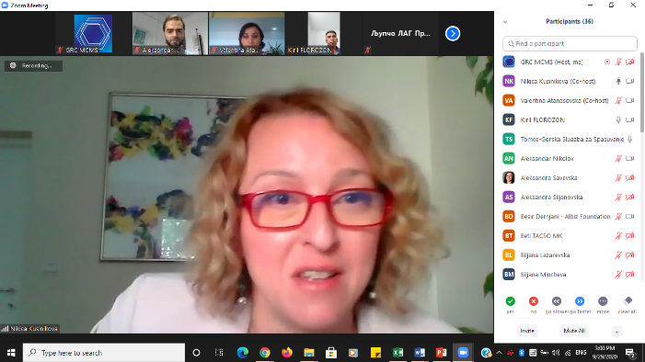According to a survey conducted by Konekt, about half of the business community receives requests for donations and the same percentage have donated in the last year, which indicates a great unrealized potential. In addition, 91% of the companies that were asked to donate donated. CSOs rarely turn to donation companies. According to the same research, donations from businesses are most often requested from individuals, for cultural events, religious bodies and sports clubs. Almost all large companies donate, although not all of them have a pre-designed donation priority. Companies mostly donate money, but they also donate material goods and services. Organisations should therefore consider different options when requesting donations. The companies donate primarily for humanitarian purposes, for treatment, sports, aid for the poor and religious bodies. However, the areas of donation also depend a lot on the preferences of managers and owners in companies. However, companies give the lowest priority in the areas of democracy and human rights. According to the research, although companies know what CSOs are (92.2%) they still rarely cooperate with organisations (15.4%), which indicates a vast potential and opens a huge opportunity for organisations to cooperate with businesses.

Nikica gave a series of tips and guidelines to organisations for establishing and maintaining business cooperation, including the following:

* Building relationships with companies requires a long-term approach and commitment.
* Organisations should not think about one-time donations, but for long-term cooperation and find opportunities for continuous upgrading of the relationship.
* Communication is the key ingredient of any good and long relationship. Communication should be regular, timely and professional. CSO jargon should not be used in communication, it should be focused on achievements, especially through specific stories about how the organisation has helped beneficiaries.
* The organisation should leave a positive impression and visibility in the public and on social media.
* The organisation should show that it has its own identity, displaying honesty.
* Although the organisation should be brave in establishing the relationship, it should not be aggressive.
* Before getting in touch with the companies, the organisation should prepare well, make a plan that it needs, but also to research the company and find out what it is interested in or what it has donated to before.
* The organisation should first identify the responsible person but also who really makes the decision, because it is often not the same person.
* At the first meeting, the physical appearance of the person should reflect the organisation he/she represents, without long speeches, but the person should bring material with him/her and in the end always express gratitude regardless of whether the meeting is successful or not.
* -When implementing, the organisation should always be realistic without many promises. It is important for the organisation to involve the companies in the implementation, if they have interest and time.
* The organisation should always express appreciation for the donation received in the most creative way possible.
* The organisation should nurture a relationship of trust, partnership and continuous cooperation.

Several examples from practice were shared on various forms of cooperation with companies such as: donations (cash or material); business support; corporate volunteering; purchase of goods and services; support in organizing special events and donation campaigns; sponsoring events of organisations; social marketing; discounts and benefits for members of the organisation.

The presentation is attached to the report, and helpful videos with practical donation tips are available at: <http://donirajpametno.mk/video-praktichni-soveti-za-pribiranje-donacii/>